**Real-Time and Image-Based Emotion Recognition**

**DESIGN PROJECT – IV**

**ECS51805**

***Submitted by***

**K.LOKESH (22112005)**

**C.C.GOVARDHAN (22112006)**

**M.HEMANTH (22112007)**

**Under the guidance of**

**Dr. K. VENKATRAMAN**

**Adjunct Professor,**

**Department of CSE.**

***In partial fulfilment for the award of the degree of***

**BACHELOR OF TECHNOLOGY**

**IN**

**COMPUTER SCIENCE AND ENGINEERING**



**HINDUSTAN INSTITUTE OF TECHNOLOGY AND SCIENCE**

**CHENNAI-603 103**

**MAY 2025**

**BONAFIDE CERTIFICATE**

Certified that this Design project report **“Real-Time and Image-Based Emotion Recognition”** is the Bonafide work of **Lokesh (22112005), Govardhan (22112006), Hemanth (22112007)** who carried out the Design project work under my supervision during the academic year 2024-2025.

|  |  |
| --- | --- |
| **HEAD OF DEPARTMENT,** | **SUPERVISOR,** |
| Dr. J.THANGAKUMAR, | DR. K.VENKATRAMAN, |
| ASSOCIATE PROFESSOR, | ADJUNCT PROFESSOR, |
| DEPARTMENT OF CSE. | DEPARTMENT OF CSE. |

**INTERNAL EXAMINER** **EXTERNAL EXAMINER**

Name: Name:

Designation: Designation:

Project Viva-Voce conducted on _________

**TABLE OF CONENTS**

|  |  |  |
| --- | --- | --- |
| **CHAPTER NO** | **TITLE** | **PAGE NO** |
|  | **ACKNOWLEDGEMENT** | 5 |
|  | **ABSTRACT** | 6 |
| 1 | **INTRODUCTION** |  |
|  | * 1. overview | 7 |
|  | 1.2 motivation of project | 7 |
|  | 1.3 objective | 8 |
|  | 1.4 summary | 8 |
| 2 | **LITERATURE REVIEW** |  |
|  | 2.1 literature review | 9 |
|  | 2.2 technical analysis of the literature | 10 |
| 3 | **MODEL DESCRIPTION** |  |
|  | 3.1 model description | 12 |
|  | 3.2 modules | 12 |
|  | 3.3 summary | 14 |
| 4 | **MODULE** |  |
|  | 4.1 website requirements | 15 |
|  | 4.2 proposed system | 16 |
|  | 4.3 hardware requirements | 16 |
| 5 | **IMPLEMENTATION** |  |
|  | 4.1 user interface | 17 |
| 6 | **RESULT ANALYSIS** |  |
|  | 6.1 output | 18 |
| 7 | **CONCLUSION AND FUTURE WORK** |  |
|  | 7.1 conclusion | 20 |
|  | 7.2 future work | 20 |
|  | **REFERENCES** | 22 |
|  | **APPENDIX** | 23 |
|  | **TEAM DETAILS** | 25 |

**Table of Figures**

|  |  |
| --- | --- |
| Figure 1: Architecture Diagram | 14 |
| Figure 2: happy face detection | **18** |
| Figure 3: Surprise face detection | **19** |
| Figure 4: Angry face detection | **19** |
| Figure 5: Sad face detection | **19** |

**ACKNOWLEDGEMENT**

First and foremost, we would like to thank **ALMIGHTY** who has provided us the strength to do justice to our work and contribute our best to it.

We wish to express our deep sense of gratitude from the bottom of our heart to our guide **Dr. K. Venkatraman , Adjunct Professor**, **Computer Science and Engineering,** for her motivating discussions, overwhelming suggestions, ingenious encouragement, invaluable supervision, and exemplary guidance throughout this design project work

We would like to extend our heartfelt gratitude to **DR. J. THANGAKUMAR, Ph.D., Professor & Head, Department of Computer Science and Engineering** for his valuable suggestions and support in successfully completing the project.

.

We thank the management of **HINDUSTAN INSTITUTE OF TECHNOLOGY AND SCIENCE** for providing us the necessary facilities and support required for the successful completion of the design project.

As a final word, we would like to thank everyone who have been a source of support and encouragement and helped us to achieve our goal and complete our design project work successfully.

**ABSTRACT**

The Face Emotion Detection project aims to detect and classify human emotions based on facial expressions using real-time video analysis. This system employs deep learning and computer vision techniques to identify emotions such as happiness, sadness, surprise, anger, and more. By using a pre-trained TensorFlow model, the system processes the facial features captured through a webcam, analyzing patterns in the face that correspond to different emotional states. The Flask web framework integrates the backend processing with a user-friendly front-end interface, displaying the detected emotion in real time.

The project provides an interactive and intuitive experience where users can see the emotion detected on their face while watching a live webcam feed. In addition, the web application allows users to upload static images for emotion analysis, making the tool versatile in both real-time and static scenarios. The website is designed with a modern, visually appealing, enhancing the overall user experience. This system serves as a practical application for understanding facial expressions, and it demonstrates the potential for real-time emotion detection in future applications such as customer feedback systems, virtual assistants, and more.

**CHAPTER-I**

**INTRODUCTION**

**1.1 OVERVIEW**

The Real-Time and Image-Based Emotion Recognition project aims to create a real-time system capable of recognizing human emotions based on facial expressions. This system utilizes computer vision and machine learning algorithms to analyze the facial features captured through a live webcam feed or uploaded images. The primary objective of the project is to develop a platform that can accurately identify emotions such as happiness, sadness, surprise, fear, anger, and disgust from a person's facial expressions.

The system is built using the Flask framework for web development, ensuring smooth user interaction. The emotion recognition model is powered by TensorFlow, leveraging pre-trained deep learning models specifically trained to detect facial expressions. The application uses a webcam feed to display the detected emotions in real time, making it highly interactive. Additionally, the platform allows users to upload images, and the system will process these images to identify the emotion expressed in the face.

This project serves as a demonstration of how machine learning and computer vision can be applied in everyday scenarios, including customer service, healthcare, and human-computer interaction. By detecting emotions in real-time, the system could be used for various practical applications, such as improving user experiences in online interactions, providing insights into emotional states, and enhancing the interactivity of virtual assistants and entertainment applications.

The user interface of the application is designed to be clean and simple, focusing on delivering accurate results with minimal delay. The use of Flask for the backend and TensorFlow for the emotion recognition model ensures that the project is scalable and can be integrated into other platforms or extended with additional features in the future.

**1.2 MOTIVATION THE PROJECT**

The motivation behind the Real-Time and Image-Based Emotion Recognition project arises from the increasing demand for emotional intelligence in human-computer interactions. In today’s fast-evolving technological landscape, understanding human emotions is crucial for creating systems that respond empathetically and intuitively. By detecting facial expressions, we can bridge the gap between human behavior and machine intelligence, enabling systems to better understand and react to users' emotional states. This can lead to more personalized and meaningful interactions, enhancing user experiences in a variety of applications, from customer service to entertainment.

The need for emotion detection technology is vast, with potential applications across multiple industries. In customer service, recognizing emotions like frustration or happiness can improve response strategies, resulting in better user satisfaction. In education, understanding a student’s emotional state could help in customizing learning approaches for more effective engagement. Additionally, emotion detection can be applied in healthcare, mental health monitoring, and even social media platforms, where it can influence content recommendations or provide early signs of emotional distress. Ultimately, this project aims to leverage computer vision and machine learning to build systems that adapt to complex emotional cues, offering a deeper and more personalized user interaction.

**1.3 OBJECTIVE**

The primary objective of the Real-Time and Image-Based Emotion Recognitionproject is to develop a system capable of detecting and analyzing human facial expressions in real-time using a webcam feed. The system aims to identify key emotions such as happiness, sadness, anger, surprise, fear, and neutral, based on the facial expressions exhibited by a user. By leveraging deep learning and computer vision techniques, the project seeks to provide accurate and instant emotion recognition, ensuring high reliability for various applications such as personalized user experiences, human-robot interaction, and mental health monitoring.

Additionally, the project intends to integrate a user-friendly interface where users can upload images for emotion detection, further extending its utility beyond live video feeds. The overall goal is to create an intuitive and interactive platform that can be seamlessly incorporated into different use cases, ranging from customer support to entertainment, improving human-computer interactions by making them more emotionally aware and adaptive.

**1.4 SUMMARY**

The Real-Time and Image-Based Emotion Recognition project focuses on developing a system that can accurately identify human emotions based on facial expressions in real time. Using advanced computer vision techniques and deep learning algorithms, the project utilizes a webcam feed to analyze facial features and predict emotions such as happiness, sadness, anger, surprise, fear, and neutral. The system is designed to offer immediate feedback, making it suitable for a wide range of applications, including mental health monitoring, personalized user experiences, and human-robot interactions.

In addition to real-time emotion detection, the project also includes an image upload feature, allowing users to submit images for emotion analysis. This enhances the versatility of the system, enabling it to function in various contexts beyond video feeds. The project aims to provide an engaging, user-friendly experience while contributing to the growing field of emotion AI, making interactions with technology more human-centric and emotionally aware.

**CHAPTER-II**

**LITERATURE REVIEW**

**2.1 LITERATURE REVIEW**

Emotion detection from facial expressions is a significant area of research in the field of Artificial Intelligence (AI) and Computer Vision. Several studies have explored the application of machine learning and deep learning models for recognizing human emotions based on facial cues. The pioneering work of Ekman and Friesen (1971) laid the foundation for understanding facial expressions, categorizing them into universal emotions such as happiness, sadness, anger, surprise, fear, and disgust. This research has been instrumental in shaping modern emotion detection systems.

In recent years, the use of Convolutional Neural Networks (CNNs) has revolutionized facial emotion detection, enabling systems to achieve high accuracy. CNNs are particularly suited for image recognition tasks due to their ability to detect hierarchical patterns in pixel data. A study by Mollahosseini et al. (2017) introduced the AffectNet dataset, which contains over a million facial images labeled with seven different emotions. This dataset has been widely used for training and testing emotion detection models.

Additionally, the advent of transfer learning has significantly improved the performance of emotion detection systems. By leveraging pre-trained models like VGG-Face and ResNet, researchers have been able to fine-tune models for emotion classification, leading to more efficient and accurate systems. A study by Zhang et al. (2020) demonstrated the use of the FER-2013 dataset for training emotion detection models, resulting in robust systems capable of handling variations in lighting, angle, and facial expression intensity.

Furthermore, recent works have integrated emotion detection systems with real-time applications, such as human-computer interaction (HCI), mental health assessment, and educational environments. Real-time emotion detection helps in building adaptive systems that respond to the user's emotional state, leading to more personalized interactions. For example, in customer service applications, emotion recognition can be used to adjust communication strategies based on the user's emotional response.

Despite these advancements, challenges remain in developing systems that can detect emotions across diverse demographics, accounting for cultural differences, and ensuring that systems are unbiased and accurate in various real-world scenarios. However, the continuous growth of datasets, algorithms, and computational power is steadily improving the reliability and application scope of emotion detection systems.

**2.2 TECHNICALL ANAYSIS OF THE LITERATURE**

The technical landscape of facial emotion detection has significantly evolved, driven by advancements in deep learning, particularly the application of Convolutional Neural Networks (CNNs) and other related architectures. The key aspect of emotion detection systems is their ability to accurately classify facial expressions, requiring both robust image processing and effective machine learning techniques.

**1. Feature Extraction and CNNs:**

A majority of the emotion detection systems employ Convolutional Neural Networks (CNNs) for feature extraction. CNNs are designed to capture spatial hierarchies in images through convolutional layers, which makes them ideal for tasks like emotion detection. A typical CNN-based emotion detection model, like the one proposed by Mollahosseini et al. (2017), involves multiple layers of convolutions, pooling, and activation functions to extract features at varying levels of abstraction. The AffectNet dataset, which consists of over a million facial images, is often used for training such models. The hierarchical feature extraction process ensures that CNNs can detect fine-grained facial expressions, which are vital for distinguishing between similar emotions like joy and surprise.

**2. Transfer Learning:**

Another notable technical advancement in emotion detection is the use of transfer learning, particularly the use of pre-trained models such as VGG-Fa**ce** or ResNet. Transfer learning allows the model to leverage knowledge from pre-trained networks on large datasets, reducing training time and improving performance. Researchers have demonstrated that fine-tuning models like VGG-Face, which was initially trained on large-scale face recognition datasets, can lead to improved emotion detection accuracy. This is especially beneficial when working with limited labeled data, as it allows for better generalization to unseen data.

**3. Datasets for Training and Evaluation:**

The quality and diversity of datasets play a crucial role in the technical performance of emotion detection systems. Datasets like **FER-2013**, **AffectNet**, and **CK+** provide a wide variety of labeled facial expression images that are essential for training robust models. The FER-2013 dataset, for instance, consists of 35,887 labeled images spanning seven emotions, which include more challenging expressions like contempt and neutral. However, the quality of these datasets also poses a technical challenge as they often contain noisy or inconsistent annotations. Moreover, some datasets may lack diversity in terms of age, ethnicity, and environmental conditions, which can affect the model's ability to generalize across different demographics.

**4. Real-Time Applications and Optimization:**

Emotion detection in real-time applications requires not only high accuracy but also computational efficiency. Real-time processing necessitates the optimization of models, often through techniques like model pruning, quantization, and hardware acceleration (e.g., GPUs). Researchers have proposed optimizations to ensure that emotion detection systems can function in environments with limited computational resources, such as mobile devices. For instance, a model designed to classify emotions in real-time must process each frame of video footage quickly, which requires the model to be computationally light while still maintaining high performance.

**5. Challenges with Emotion Recognition:**

Despite the technical progress, emotion recognition systems still face challenges. One of the primary concerns is cultural variability, as facial expressions may differ across cultures, potentially leading to biases in emotion classification. This necessitates the inclusion of diverse training data that represents a wide range of ethnicities, ages, and cultural backgrounds. Additionally, emotion detection systems often struggle with ambiguous facial expressions or subtle differences in emotions, such as distinguishing between surprise and fear. Models trained on large datasets like AffectNet or FER-2013 may perform well in controlled environments but can exhibit poor performance under real-world conditions, where variations in lighting, facial occlusions (like glasses or masks), and diverse expressions come into play.

**6. Integration with Other Modalities:**

An emerging trend in emotion detection research is the integration of multiple modalities beyond just facial expressions. Multimodal emotion recognition, which combines facial expressions, voice tone, and body language, is proving to be more robust than single-modal systems. A study by Zhang et al. (2020) proposed a multimodal approach that combines CNNs for facial emotion detection with Recurrent Neural Networks (RNNs) for analyzing speech. This approach provides a more comprehensive analysis of a person's emotional state, enabling more accurate emotion classification in dynamic, real-world scenarios.

**CHAPTER-III**

**MODEL DESCRIPTION**

**3.1 MODEL DESCRIPTION**

The core of this face emotion detection system is a deep learning model trained using TensorFlow and Keras. The model’s trained weights are stored in a file, which represents a feedforward neural network optimized for classifying human facial expressions. This .h5 file contains the learned weights and optimizer states but does not encapsulate the model architecture. The architecture was manually defined in code to ensure compatibility during loading.

The neural network consists of three fully connected dense layers. Each layer is composed of neurons that perform weighted summation of inputs followed by an activation function, enabling the model to learn complex patterns in facial features. The first two dense layers serve as feature extractors, transforming input data into higher-dimensional representations. The final dense layer outputs the probability distribution over different facial emotion classes like Happy, Sad, Angry, Surprise, Neutral, etc.

Before passing the image to the model, we apply face detection using OpenCV’s haarcascade_frontalface_default.xml classifier. This Haar Cascade Classifier efficiently detects faces in the image or video stream by scanning the image with a 24x24 window and evaluating multiple stages of weak classifiers. Only regions that pass all stages are considered potential faces, thereby reducing false positives and increasing processing speed.

Once a face is detected, it is preprocessed—converted to grayscale, resized to a fixed input shape (e.g., 48x48 pixels), and normalized. This preprocessed image is then fed into the neural network for classification. The model outputs a label corresponding to the detected emotion along with a confidence score.

In real-time applications, such as webcam feed processing, the model continuously receives new face regions, processes them, and dynamically updates the predicted emotion label on the display. This architecture makes the system suitable for responsive user interaction, live feedback, or psychological research studies.

**3.2 MODULES**

**1. Frontend Modules**

These modules handle the user interface and interactions.

**a. Input Interface**

* Provides a simple UI to allow users to either upload an image or access their webcam feed.
* Uses HTML and JavaScript to trigger webcam or file input actions.
* Displays the video stream or uploaded image on the browser.

**b. Output Display**

* Shows the detected emotion on the screen in real-time.
* Draws a rectangle around the detected face and overlays the predicted emotion as text.
* Uses JavaScript for canvas rendering and dynamic updates.

**c. Styling and Layout**

* Designed using CSS with Gen Z-inspired visuals: black background with gradient effects.
* Ensures responsiveness and cross-device compatibility.

**2. Backend Modules**

These modules handle the processing and logic behind the scenes.

**a. Face Detection**

* Uses the Haar Cascade Classifier to identify frontal faces from the input.
* Converts input images/frames to grayscale for efficient processing.

**b. Preprocessing**

* Crops and resizes the detected face region to match model input dimensions.
* Normalizes the image data for accurate prediction.

**c. Emotion Detection Model**

* Loads the pre-trained Keras model from the pre-trained model file.
* Predicts the emotion category of the detected face (e.g., happy, sad, angry).
* The model consists of three dense layers trained on facial emotion datasets.

**d. Integration & Serving**

* The backend is built using Flask.
* Manages routing between the user interface and the ML model.
* Sends the prediction results back to the frontend for display.

**3.3 SUMMARY**

This project focuses on developing a real-time **face emotion detection system** that can accurately identify human emotions based on facial expressions. Leveraging computer vision and deep learning, the system captures live video or image input, detects faces using the Haar Cascade Classifier, and classifies the detected facial expressions using a pre-trained deep learning model (Black_Box.h5). The interface is built using HTML, CSS, and JavaScript, while Flask is used as the backend to handle real-time webcam feed and image upload functionality.

This application demonstrates the potential of integrating machine learning models with real-time web technologies for human-computer interaction. It has wide applications in sectors like education, marketing, mental health analysis, and user experience personalization. The modularity and simplicity of this system make it easily extendable to more complex use cases, such as sentiment-aware assistants, emotion-driven chatbots, or smart surveillance systems.

**3.4 ARCHITECTURE DIAGRAM**

**Fig 1:**architecture diagram

**CHAPTER-IV**

**MODULE**

**4.1 WEBSITE REQUIREMENTS**

**Frontend Requirements**

* A responsive and user-friendly interface using **HTML**, **CSS**, and **JavaScript**
* Live video feed integration from the webcam
* File upload option for static image-based emotion detection
* Real-time display of detected emotions on the same page
* Error handling and feedback display (like "No face detected", etc.)

**Backend Requirements**

* **Flask** web framework (Python) to handle routes and rendering
* Integration of the trained model (Black_Box.h5) for emotion prediction
* OpenCV integration for real-time face detection
* Haar Cascade XML (haarcascade_frontalface_default.xml) for detecting frontal faces
* Numpy and TensorFlow/Keras for preprocessing and model inference
* Real-time communication between frontend and backend
* Static image processing and response handling

**Functional Requirements**

* Predict and display the emotion on screen
* Allow users to upload an image and detect emotion from it
* Handle unknown or no-face cases gracefully

**Non-Functional Requirements**

System-related expectations:

* Fast response time (< 1 sec for predictions)
* Should work on major browsers (Chrome, Firefox, Edge)
* Secure access to user webcam (with permission prompt)
* Lightweight and minimal dependencies for better performance

**4.2 PROPOSED SYSTEM**

The proposed system is a real-time **Face Emotion Detection Web Application** that allows users to either stream live video from their webcam or upload an image to detect human facial expressions. It utilizes machine learning and deep learning techniques, along with traditional image processing methods, to analyze facial features and classify emotions such as **Happy, Sad, Angry, Neutral**, and more.

This system is built using a **modular approach**, combining **frontend technologies (HTML, CSS, JavaScript)** for a dynamic and intuitive user interface, and **backend technologies (Python, Flask)** for real-time data handling and model inference. A pre-trained deep learning model is used for emotion classification, while face detection is accomplished using OpenCV's Haar Cascade classifier .

The main goal of the proposed system is to deliver an efficient, accurate, and easy-to-use emotion detection solution that can work in real-time and handle both video and image inputs. The model is designed to recognize emotions from frontal faces and update the results instantly on the web interface. By integrating all these components into a single-page web app, the system aims to be accessible, fast, and user-centric.

Additionally, the system maintains separation between frontend and backend operations for scalability and clarity. The entire architecture has been optimized for quick detection and low latency to provide immediate feedback to users.

**4.3 HARDWARE REQUIREMENTS**

1. **Webcam:**
   * A **high-definition webcam** (720p or higher) for clear facial expression capture.
2. **Processor:**
   * A **multicore processor** (preferably i5 or higher) to handle both the real-time processing of video and running the emotion detection model.
3. **RAM:**
   * At least **8GB RAM**, but for smoother multitasking (running browser, backend, etc.), **16GB** is preferred, especially when running real-time models.
4. **Software Tools:**
   * Installations of **TensorFlow**, **OpenCV**, **Flask**, and other dependencies.
   * Ensure the environment is capable of supporting both frontend (HTML, CSS, JS) and backend (Flask, Python) processing.

**CHAPTER-V**

**IMPLEMENTATION**

**5.1 USER INTERFACE**

**Implementation**

The Face Emotion Detection system integrates backend (Flask), machine learning (CNN model), and frontend (HTML, CSS, JavaScript) components for real-time emotion recognition.

1. **Backend (Flask):**
   * Flask handles HTTP requests, processes uploaded images, and interacts with the emotion detection model.
   * The uploaded image is converted into grayscale, faces are detected using Haar cascades, and the image is resized to match the model’s input.
   * The pre-trained CNN model predicts emotions like Anger, Happiness, and Sadness, and the result is returned to the frontend.
2. **Emotion Detection Model:**
   * The model is a CNN trained on datasets like FER-2013 or AffectNet.
   * It processes facial images and predicts emotions based on features extracted from the image.
3. **Frontend (HTML/CSS/JS):**
   * The user uploads an image, which is sent to the backend using AJAX.
   * Once the emotion is detected, the frontend dynamically updates the page to display the result, ensuring smooth interaction.
4. **Integration:**
   * The frontend collects the image, the backend processes it, and the emotion result is displayed to the user in real-time.
5. **Optimization:**
   * Model optimization ensures efficient performance, and face detection ensures only faces are processed for accurate predictions.

**CHAPTER-VI**

**RESULT ANALYSIS**

**6.1 OUTPUT**

• **Real-Time Emotion Detection**:

* The system continuously detects emotions from the webcam feed.
* As the user interacts with the webcam, it shows the current emotion detected on the screen, updating in real-time.

• **Image Upload Emotion Detection**:

* The user can upload a picture, and the system processes it to detect the emotion from the face in the image.
* Once processed, the emotion is displayed on the screen with a message like "Emotion Detected: HAPPY".

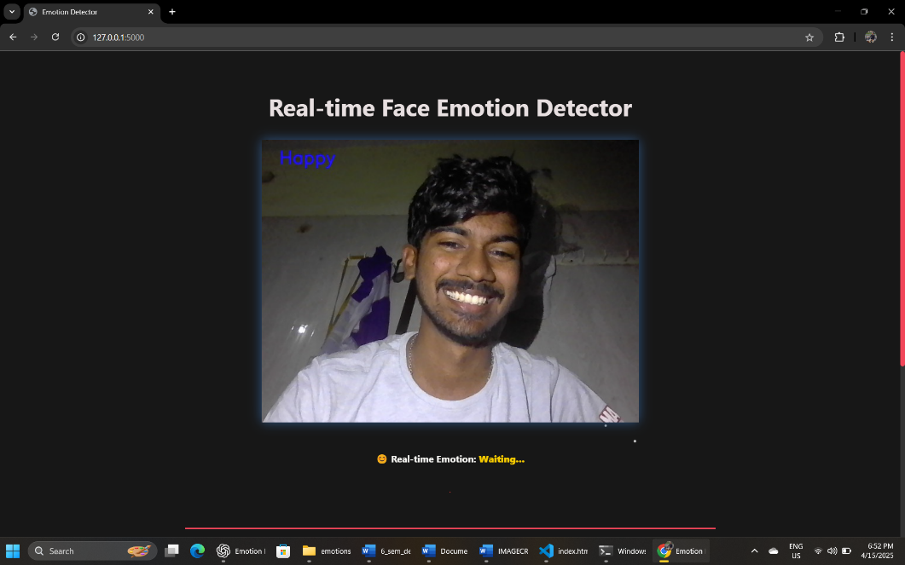

**Fig 2:**Happy emotion detection(live feed)

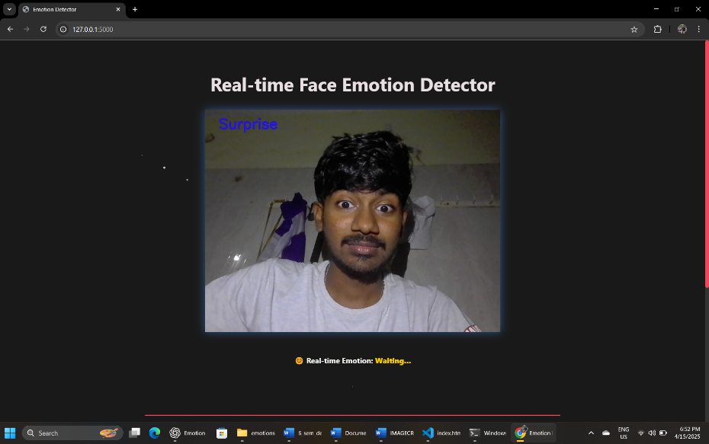

**Fig 3:**Surprise face detection(live feed)

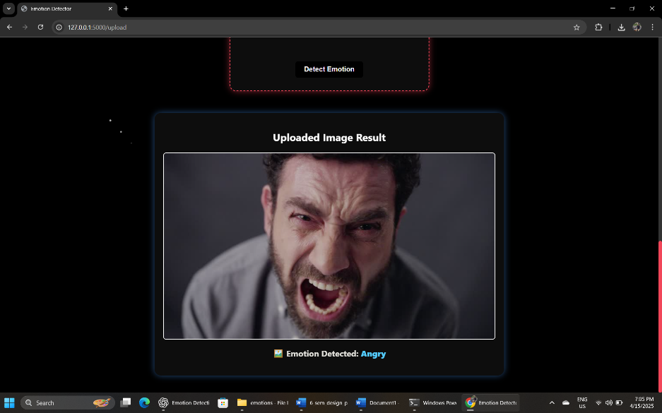

**Fig 4:**Angry face detection(image-upload)

**Fig 5:**Sad face detection(image-upload)

**CONCLUSION AND FUTURE WORK**

**CONCLUSION**

The Face Emotion Detection system successfully integrates machine learning, computer vision, and web development technologies to create an interactive platform that detects and classifies emotions in real-time. The system works by processing webcam feeds and uploaded images to identify the emotions displayed on a person's face. It utilizes a Convolutional Neural Network (CNN) model trained on facial expression datasets, such as FER-2013, to predict emotions like Anger, Happiness, Sadness, Surprise, and more. By leveraging Flask for the backend, the system efficiently handles image processing and emotion prediction, providing an engaging user experience.

The system features both real-time emotion detection via webcam and the ability to upload images for emotion analysis. These functionalities ensure that users can interact with the system in multiple ways, making it flexible and adaptable to different needs. The frontend is built using HTML, CSS, and JavaScript, ensuring smooth interaction through asynchronous HTTP requests, which eliminates the need for page reloads and allows for quick and dynamic feedback.

Additionally, the project addresses performance and optimization concerns by using face detection algorithms to focus on the face and filter out irrelevant background noise, ensuring more accurate predictions. The overall design ensures that the system runs efficiently, even when processing images in real-time. It is highly optimized to balance accuracy and speed, providing users with immediate feedback on detected emotions.

**FUTURE WORK**

1. **Multi-Face Detection**: Currently, the system detects emotions based on a single face. Future improvements could include the ability to detect and classify emotions from multiple faces within a single image or video feed. This would be beneficial for group settings or environments where interactions involve multiple people, such as in classrooms or meetings.
2. **Enhanced Emotion Categories**: The current system classifies basic emotions like Happiness, Sadness, Anger, and Surprise. Future work could focus on extending the model to include more nuanced emotions, such as Disgust, Fear, Contempt, and Neutral expressions, to make the emotion detection more comprehensive and accurate.
3. **Integration with AI-Driven Feedback**: The system could be expanded to provide AI-driven recommendations or feedback based on the detected emotions. For example, if the system detects sadness or stress, it could suggest relaxing music, motivational quotes, or other personalized responses. This could open up possibilities for mental health applications or personalized user experiences.
4. **Real-Time Video Processing**: While the system currently works with images and webcam feeds, real-time video processing could enhance the user experience. By processing a stream of video frames in real-time, the system could track emotional changes over time, providing a dynamic emotional analysis throughout the duration of a video.
5. **Mobile Application Development**: To make the system more accessible, it could be ported to a mobile application. This would allow users to easily upload images or use the camera on their smartphones for emotion detection, expanding the reach of the system beyond desktop users.
6. **Voice Emotion Recognition**: Integrating voice emotion recognition alongside facial emotion detection could create a more holistic understanding of a person’s emotional state. By analyzing tone, pitch, and speed of speech, the system could correlate facial expressions and voice tone to provide a more accurate and complete emotion profile.
7. **Improved Model Accuracy**: The system's accuracy could be enhanced by fine-tuning the emotion detection model using larger, more diverse datasets, or by adopting more advanced architectures like Transfer Learning with pre-trained models such as VGG or ResNet. Additionally, continuous learning methods could be implemented to update the model as more data is collected, improving its robustness.
8. **Ethical and Privacy Considerations**: Future development should also take into account the ethical implications of emotion detection, particularly with regard to privacy and consent. Systems like these should ensure that user data is anonymized, secure, and only used for intended purposes. Additionally, transparent policies should be established to ensure users' trust in the system.

**REFERENCES**

1. **Ethical Considerations in AI and Emotion Detection**

* Crawford, K., & Calo, R. (2016). *There is a blind spot in AI research*. Nature, 538(7623), 317–319.
* DOI: 10.1038/538317a

2. **Mobile Application Development for Emotion Detection**

* Witting, K., & Wimmer, H. (2014). *Mobile Applications for Affective Computing*. Springer, International Conference on Affective Computing and Intelligent Interaction.
* DOI: 10.1007/978-3-319-11964-9_32

3. **Real-Time Emotion Detection with OpenCV**

* Satya Mallick. (2017). *Real-time Emotion Detection Using OpenCV*. LearnOpenCV.

4. **TensorFlow for Deep Learning**

* Chollet, F. (2017). *Deep Learning with Python*. Manning Publications.

5. **Flask Web Framework Documentation**

* Grinberg, M. (2018). *Flask Web Development: Developing Web Applications with Python*. O'Reilly Media.

**APPENDIX**

**Sample code**

from flask import Flask, render_template, Response, request, redirect, url_for

import cv2

import numpy as np

from keras.models import load_model

from tensorflow.keras.preprocessing.image import img_to_array

from werkzeug.utils import secure_filename

import os

app = Flask(__name__)

camera = cv2.VideoCapture(0)

# Load the model

model = load_model("Black_Box.h5")

emotion_labels = ['Angry', 'Disgust', 'Fear', 'Happy', 'Neutral', 'Sad', 'Surprise']

last_emotion = "Waiting..."

# Upload folder config

UPLOAD_FOLDER = 'static/uploaded'

app.config['UPLOAD_FOLDER'] = UPLOAD_FOLDER

os.makedirs(app.config['UPLOAD_FOLDER'], exist_ok=True)

# Load Haar cascade

face_cascade = cv2.CascadeClassifier(cv2.data.haarcascades + 'haarcascade_frontalface_default.xml')

if face_cascade.empty():

print("Error: Haar Cascade is not loaded properly")

def predict_emotion(face):

global last_emotion

try:

# Check image shape

print(f"Image shape: {face.shape}")

face_gray = cv2.cvtColor(face, cv2.COLOR_BGR2GRAY)

faces = face_cascade.detectMultiScale(face_gray, 1.3, 5)

if len(faces) == 0:

return "No Face Detected"

for (x, y, w, h) in faces:

            roi_gray = face_gray[y:y + h, x:x + w]

            roi_gray = cv2.resize(roi_gray, (48, 48), interpolation=cv2.INTER_AREA)

            if np.sum([roi_gray]) != 0:

                roi = roi_gray.astype('float') / 255.0

                roi = img_to_array(roi)

                roi = np.expand_dims(roi, axis=0)

                prediction = model.predict(roi)[0]

                label = emotion_labels[prediction.argmax()]

                last_emotion = label

                return label

    except cv2.error as e:

        print(f"Error in predict_emotion: {e}")

        return "Error in face detection"

    return "No Face Detected"

**Team Details:**

**Team member 1:**

Name : C.C.Govardhan

Class:CSE-6A

Roll no:22112006

Email:22112006@student.hindustanuniv.ac.in

Contact No:8309048948

**Team member 2:**

Name : K. Lokeshwar Reddy

Class:CSE-6A

Roll no: 22112005

Email:2211005@student.hindustanuniv.ac.in

Contact No:9392258426

**Team member 3:**

Name : M. Hemanth Kumar

Class:CSE-6A

Roll no:22112007

Email:22112007@student.hindustanuniv.ac.in

Contact No:9391515783